Packet Tracer - Configuring IPv4 Route Summarization - Scenario 1

1. Topology

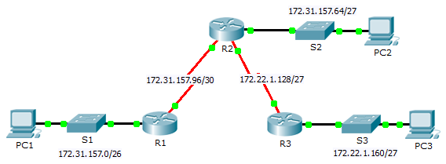

1. Addressing Table

|  |  |  |  |  |
| --- | --- | --- | --- | --- |
| Device | Interface | IPv4 Address | Subnet Mask | Default Gateway |
| R1 | G0/0 | 172.31.157.1 | 255.255.255.192 | N/A |
| S0/0/0 | 172.31.157.97 | 255.255.255.252 | N/A |
| R2 | G0/0 | 172.31.157.65 | 255.255.255.224 | N/A |
| S0/0/0 | 172.31.157.98 | 255.255.255.252 | N/A |
| S0/0/1 | 172.22.1.129 | 255.255.255.224 | N/A |
| R3 | G0/0 | 172.22.1.161 | 255.255.255.224 | N/A |
| S0/0/1 | 172.22.1.158 | 255.255.255.224 | N/A |
| PC1 | NIC | 172.31.157.62 | 255.255.255.192 | 172.31.157.1 |
| PC2 | NIC | 172.31.157.94 | 255.255.255.224 | 172.31.157.65 |
| PC3 | NIC | 172.22.1.190 | 255.255.255.224 | 172.22.1.161 |

1. Objectives

Part 1: Calculate Summary Routes

Part 2: Configure Summary Routes

Part 3: Verify Connectivity

1. Background

In this activity, you will calculate and configure summary routes. Router summarization, also known as route aggregation, is the process of advertising a contiguous set of addresses as a single address.

1. Calculate Summary Routes
   1. Calculate a summary route on R1 to reach LANs on R3.
      1. List the 172.22.1.128/27 and 172.22.1.160/27 networks in binary format.

172.22.1.128: 10101100.00010110.00000001.10000000

172.22.1.160: 10101100.00010110.00000001.10100000

* + 1. Count the left-most matching bits to determine the mask for the summary route. They have 26 left-most bits in common.

172.22.1.128: **10101100.00010110.00000001.10**000000

172.22.1.160: **10101100.00010110.00000001.10**100000

* + 1. Copy the matching bits and fill in the remaining bits with zeros to determine the summarized network address.

10101100.00010110.00000001.10000000

* + 1. What is the summarized network address and subnet mask? ___________________________________
  1. Calculate a summary route on R3 to reach LANs on R1 and R2.
     1. Calculate the summary route for the 172.31.157.0/26, 172.31.157.64/27, and 172.31.157.96/30 networks. List the networks in binary format. Then, count the left-most matching bits to determine the mask for the summary route.

____________________________________________________________________________________

____________________________________________________________________________________

____________________________________________________________________________________

* + 1. What is the summarized network address and subnet mask? ___________________________________

1. Configure Summary Routes
   1. Configure a summary route for R1.

Configure the recursive summary route that you calculated in Part 1, Step 1.

* 1. Configure a summary route for R3.

Configure the directly attached summary route that you calculated in Part 1, Step 2.

1. Verify Connectivity

Verify that all PC hosts and routers can ping other PC hosts and routers in the topology. If not, troubleshoot and correct the issues.